IPL Matches & Deliveries SQL Queries
2008-2024
- Total number of unique seasons
SELECT COUNT(DISTINCT season) AS Total_Seasons FROM matches;
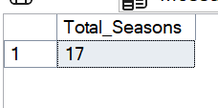
2.Total number of matches played
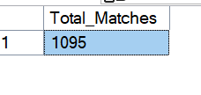
SELECT COUNT(*) AS Total_Matches FROM matches;
3. Total number of unique venues
SELECT COUNT(DISTINCT venue) AS Unique_Venues FROM matches;
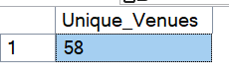
4. Number of matches won by each team
SELECT winner, COUNT(*) AS Matches_Won
FROM matches
GROUP BY winner
ORDER BY Matches_Won
DESC;
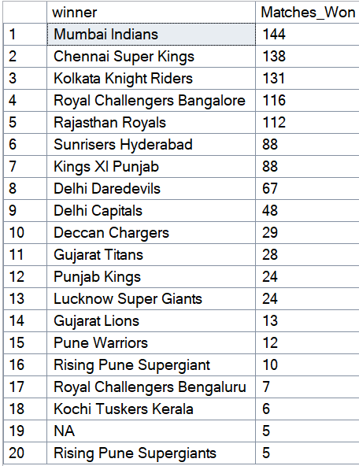

5. Top 5 players with most 'Player of the Match' awards
SELECT TOP 5 player_of_match, COUNT(*) AS Awards
FROM matches
GROUP BY player_of_match
ORDER BY Awards DESC;
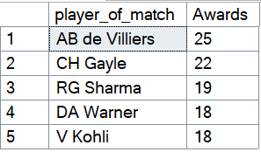

6. Number of matches played per season
SELECT season, COUNT(*) AS Matches_Played
FROM matches
GROUP BY season
ORDER BY season;
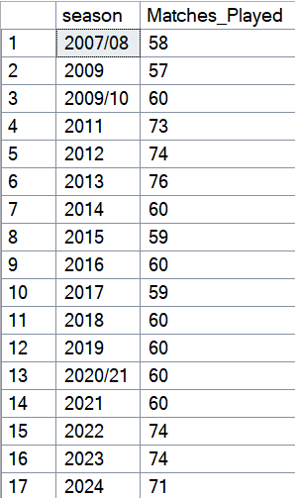
7. Toss decision count (bat/field)
SELECT toss_decision, COUNT(*) AS Count
FROM matches
GROUP BY toss_decision;
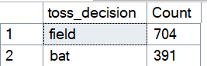

8. Matches won by toss winner
SELECT COUNT(*) AS Toss_Winner_Wins
FROM matches
WHERE toss_winner = winner;
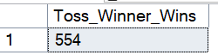

9. Teams with most match wins at Wankhede Stadium
SELECT winner, COUNT(*) AS Wins
FROM matches
WHERE venue = 'Wankhede Stadium'
GROUP BY winner
ORDER BY Wins
DESC;
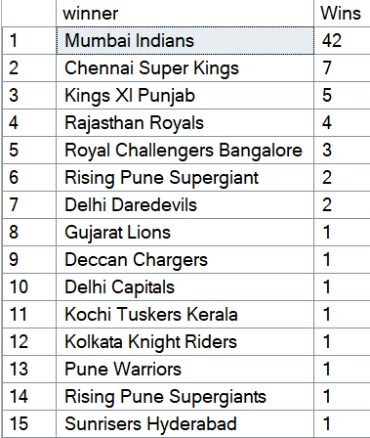
10. Most frequent venue for IPL matches
SELECT TOP 1venue, COUNT(*) AS Matches_Hosted
FROM matches
GROUP BY venue
ORDER BY Matches_Hosted
DESC


11. Total runs scored in all IPL matches
SELECT SUM(total_runs) AS Total_Runs FROM deliveries;
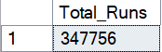

12. Total number of sixes hit
SELECT COUNT(*) AS Total_Sixes
FROM deliveries
WHERE batsman_runs = 6;


13. Total number of fours hit
SELECT COUNT(*) AS Total_Fours
FROM deliveries
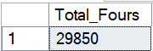
WHERE batsman_runs = 4;

14 Top 5 batsmen with most sixes
SELECT TOP 5 batter, COUNT(*) AS Sixes
FROM deliveries
WHERE batsman_runs = 6
GROUP BY batter
ORDER BY Sixes
DESC
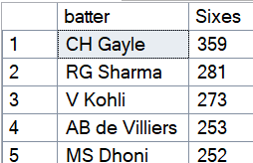

15. Most runs conceded by Top5 bowlers
SELECT TOP 5 bowler,
SUM(total_runs) AS Runs_Conceded
FROM deliveries
GROUP BY bowler
ORDER BY Runs_Conceded
DESC;
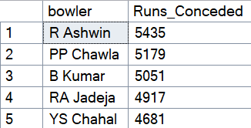

16. Top 5 batsmen by total runs
SELECT TOP 5 batter, SUM(batsman_runs) AS Total_Runs FROM deliveries
GROUP BY batter
ORDER BY Total_Runs
DESC
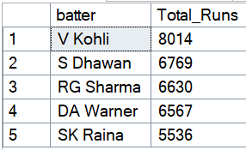
17. Batsman with most dot balls faced
SELECT top 5 batter, COUNT(*) AS Dot_Balls FROM deliveries
WHERE total_runs = 0 GROUP BY batter
ORDER BY Dot_Balls
DESC ;
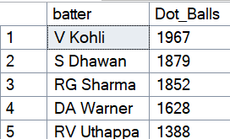

18. Extras conceded by each team
SELECT Top 5 bowling_team, SUM(extra_runs) AS Extras_Conceded
FROM deliveries
GROUP BY bowling_team
ORDER BY Extras_Conceded
DESC;
